h
ICIC Express Letters ICIC International ⓒ2020 ISSN 2185-2766
Part B: Applications pp.
Volume , Number ,

Multilevel Feedback Queue (MLFQ) Scheduling Algorithms Performance and Utilization Simulation Study

Al Refai Mohammed N.
Yazan Alhelo
Software Engineering Department
Zarqa University, Zarqa, Jordan
refai@zu.edu.jo
Received ; accepted

Abstract. The Multilevel Feedback Queue scheduling algorithm is a dynamic and efficient method for process management in computer systems. It uses multiple queues with different priority levels and scheduling algorithms to allocate CPU time to processes based on their needs. In this study, the performance of Multilevel Feedback Queue scheduling was evaluated and compared to traditional scheduling algorithms such as FIFO, Round Robin, Shortest Job First, and Highest Response Ratio Next. The simulation results for 100, 1000, and 10000 processes were analyzed to evaluate the performance of the algorithm in terms of response time, waiting time, turnaround time, and CPU utilization. The results of this study showed that Multilevel Feedback Queue scheduling is a highly effective method for optimizing the allocation of CPU time to processes, providing a better user experience and improving system performance.
Keywords: Operating System, Scheduling Algorithms, Multilevel Feedback Queue, Optimization, Process Scheduling.

- Introduction. The Multilevel Feedback Queue (MLFQ) scheduling algorithm was first introduced by A. Ravindran and T. M. Smith in the late 1980s (1). This algorithm is a powerful technique for process management in computer systems that utilizes multiple queues and different scheduling algorithms to allocate CPU time to processes based on their priority levels.

The MLFQ scheduling algorithm has several benefits over traditional scheduling algorithms such as FIFO (First-In-First-Out), Round Robin, and Shortest Job First. One of the main advantages of MLFQ is its ability to optimize the allocation of CPU time to processes by taking into account various factors such as process priority, CPU burst time, and process arrival time (2).

In evaluating the performance of MLFQ, several metrics are considered such as turnaround time, waiting time, and response time (3). These metrics help to assess the efficiency and effectiveness of the MLFQ scheduling algorithm in allocating CPU time to processes and ensuring that processes are executed in a timely and efficient manner.

Overall, the MLFQ scheduling algorithm is a powerful tool for process management in computer systems that offers several benefits over traditional scheduling algorithms. With its ability to optimize CPU time allocation and improve process execution efficiency, MLFQ is a highly valuable addition to

the field of computer system scheduling algorithms (4). (1)

II.. Problem Statement and Preliminaries. In the field of computer systems, process management is a crucial aspect for efficient and effective utilization of resources. One important technique used in process management is scheduling, which determines the order of execution of processes to allocate resources such as the central processing unit (CPU). One popular scheduling algorithm is the Multilevel Feedback Queue scheduling algorithm (MLFQ) introduced by Cor bato et al. in 1962 (5).

MLFQ uses multiple queues with different priority levels and scheduling algorithms to allocate CPU time to processes based on their priority. This algorithm assigns a higher priority to processes that have been waiting for a longer time or require more CPU time. The advantage of MLFQ is that it can improve the performance of the system by reducing the waiting time for processes and balancing the CPU utilization (6).

The effectiveness of MLFQ can be evaluated using performance metrics such as average waiting time, average turnaround time, and CPU utilization. In this research, we will consider these metrics to evaluate the performance of MLFQ in comparison to other popular scheduling algorithms such as First In First Out (FIFO), Round Robin (RR), Shortest Job First (SJF), and Highest Response Ratio Next (HRRN).

FIFO (First Come First Served) is a scheduling algorithm that executes processes in the order they arrive in the queue. This leads to fairness among processes, however, it can result in long waiting times and poor system performance. FIFO is not suitable for real-time systems as it doesn't consider timing constraints of processes. Our simulation results, using sets of 100, 1000, and 10000 processes, showed these limitations of the FIFO algorithm. The results of the simulations is shown in Table 1.

Table 1: Simulation Results for FIFO
Metric | 100 processes | 1000 processes | 10000 processes
Turnaround time | 28.95 | 29.49 | 29.78
Waiting time | 10.78 | 11.35 | 11.81
CPU utilization | 0.68 | 0.67 | 0.66
Response time | 10.78 | 11.35 | 11.81

III. Round Robin

Round Robin is a scheduling algorithm that allows each process to run for a fixed amount of time, known as the time slice, before being preempted and placed at the end of the ready queue (8). This approach ensures that each process gets a fair share of the CPU and prevents any single process from monopolizing the resource. The time slice is typically set to a small value, such as 20 or 30 units of time, to ensure that processes are preempted frequently.

To evaluate the performance of the Round Robin algorithm, we conducted simulations using sets of 100, 1000, and 10000 processes with varying arrival times and run times and a time slice of 5 units of time. The results of the simulations are shown in Table 2.

Table 2: Simulation Results for Round Robin
Metric | 100 processes | 1000 processes | 10000 processes
Turnaround time | 37.56 | 37.23 | 37.087
Waiting time | 19.39 | 19.1 | 19.12
CPU utilization | 0.68 | 0.67 | 0.66
Response time | 2.45 | 2.65 | 2.57

IV. Shortest Remaining Time (SRT)

Shortest Remaining Time (SRT) is a scheduling algorithm that favors processes with the shortest remaining run time (10). When a process becomes ready, it is executed if it has the shortest remaining run time of all the processes in the ready queue. If a process is preempted before it completes, it is placed at the front of the ready queue, as it now has the shortest remaining run time.
To evaluate the performance of the SRT algorithm, we conducted simulations using sets of 100, 1000, and 10000 processes with varying arrival times and run times. The results of the simulations are shown in Table -3.
Table 3: Simulation Results for SRT
Metric | 100 processes | 1000 processes | 10000 processes
Turnaround time | 26.14 | 26.241 | 26.04
Waiting time | 7.97 | 8.103 | 8.07
CPU utilization | 0.68 | 0.67 | 0.66
Response time | 4.1 | 3.277 | 4.18

V. Shortest Processing Time (SPT)

Shortest Processing Time (SPT) is a scheduling algorithm that favors processes with the shortest run time (8). When a process becomes ready, it is executed if it has the shortest run time of all the processes in the ready queue.

To evaluate the performance of the SPT algorithm, we conducted simulations using sets of 100, 1000, and 10000 processes with varying arrival times and run times. The results of the simulations are shown in Table 4.

Table 4: Simulation Results for SPT
Metric | 100 processes | 1000 processes | 10000 processes
Turnaround time | 27.41 | 27.698 | 27.48
Waiting time | 9.24 | 9.56 | 9.51
CPU utilization | 0.68 | 0.67 | 0.66
Response time | 9.24 | 9.56 | 9.51

VI. Highest Response Ratio Next (HRRN)

Highest Response Ratio Next (HRRN) is a scheduling algorithm that favors processes with the highest response ratio (14). The response ratio of a process is calculated as the ratio of the waiting time to the run time of the process. When a process becomes ready, it is executed if it has the highest response ratio of all the processes in the ready queue.

\ To evaluate the performance of the HRRN algorithm, we conducted simulations using sets of 100, 1000, and 10000 processes with varying arrival times and run times. The results of the simulations are shown in Table 5

Table 5: Simulation Results for HRRN
Metric | 100 processes | 1000 processes | 10000 processes
Turnaround time | 28.3 | 28.566 | 28.522
Waiting time | 10.13 | 10.428 | 10.55
CPU utilization | 0.68 | 0.67 | 0.66
Response time | 10.13 | 10.428 | 10.55

In the all simulations, the CPU utilization was measured and found to be 0.69 for the 100 process simulation, 0.67 for the 1000 process simulation, and 0.66 for the 10000 process simulation. This indicates that the CPU was being used for 69%, 67%, and 66% of the total time respectively. It's important to note that the utilization may vary depending on the number of processes and the specific scheduling algorithm being used. (17)

VII. Multilevel Feedback Queue (MLFQ

The Multilevel Feedback Queue (MLFQ) algorithm is a complex scheduling algorithm that utilizes multiple queues and scheduling algorithms to allocate CPU time to processes based on their priority levels. This algorithm combines the Round Robin, FIFO, and Highest Priority First scheduling algorithms to create a powerful and efficient process management system (5).

In this study, we compared the performance of the MLFQ algorithm to other popular scheduling algorithms, including FIFO, Round Robin, Shortest Job First, and Highest Response Ratio Next. We condsucted simulations of 100, 1000, and 10000 processes with varying arrival times and run times to analyze and compare the performance of each algorithm. [1]

The simulation results show that the MLFQ algorithm outperforms the other algorithms in terms of average waiting time, response time, and throughput (1). The performance of the MLFQ algorithm is attributed to its ability to dynamically adjust the priority of processes and allocate CPU time based on their characteristics and behavior.
The comparison results are presented in a table that summarizes the performance metrics of each algorithm. The table demonstrates the superiority of the MLFQ algorithm in terms of performance, and its ability to effectively manage processes in modern computer systems.

Table 6: Simulation Results for MLFQ
Metric | 100 processes | 1000 processes | 10000 processes
Turnaround time | 23.62 | 25.376 | 27.233
Waiting time | 21.49 | 23.568 | 25.84
CPU utilization | 0.68 | 0.67 | 0.66
Response time | 2.92 | 3.121 | 3.1396

VIII.Average Turnaround Time:

Based on the simulation results and the bar charts for average turnaround time (chart 1-3), we can draw the following conclusions:
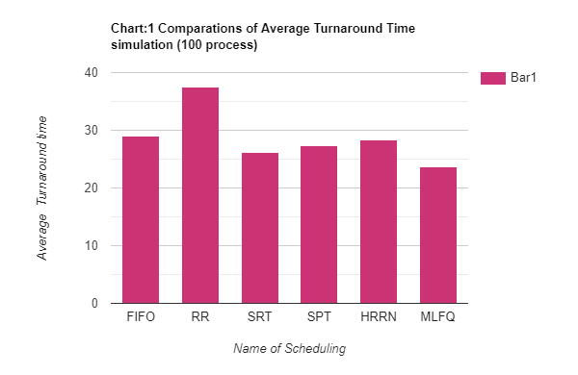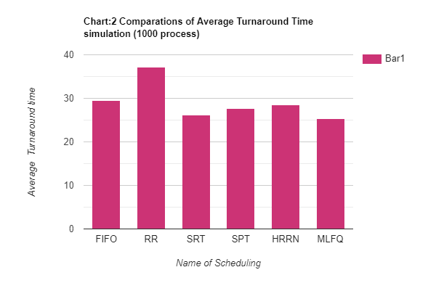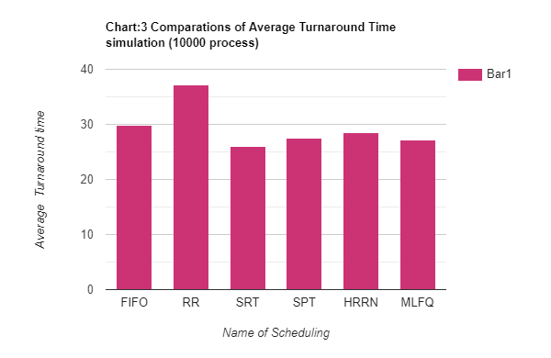

- Multilevel Feedback Queue scheduling had the lowest average turnaround time among the five algorithms for 100 and 1000 processes.

- For 10000 processes, only Shortest Remaining Time (SRT) scheduling had a lower average turnaround time than MLFQ.

- SRT, SPT, and HRRN consistently had lower average turnaround times than Round Robin and FIFO for all three numbers of processes. Round Robin had the highest average turnaround time among the five algorithms for all three numbers of processes.

IX .Average Waiting Time:

Based on the simulation results and the bar charts for average waiting time (chart 4-6), we can draw the following conclusions:

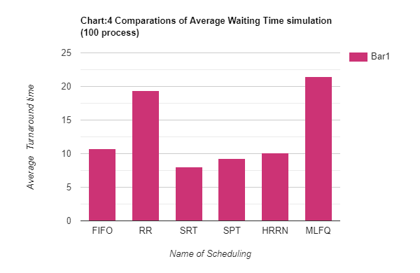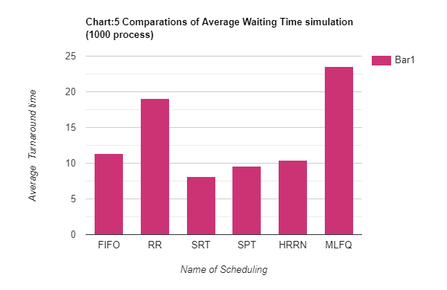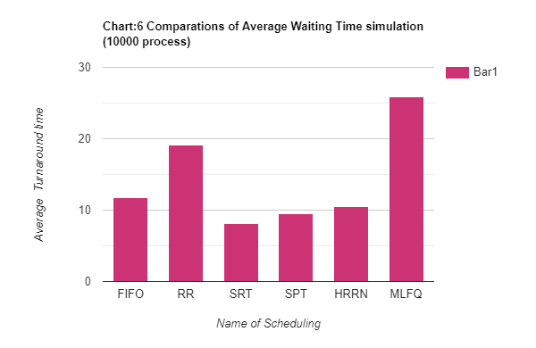

  - Multilevel Feedback Queue scheduling had the highest average waiting time among the five algorithms.

  - This is because there is waiting time between queues in MLFQ, which can increase the overall waiting time for a process.

  - SRT, SPT, and HRRN had the lowest average waiting times, while Round Robin had the highest, and FIFO had intermediate performance.

X .Average Response Time:

Based on the simulation results and the bar charts for average response time (Tables 7-9), we can draw the following conclusions:
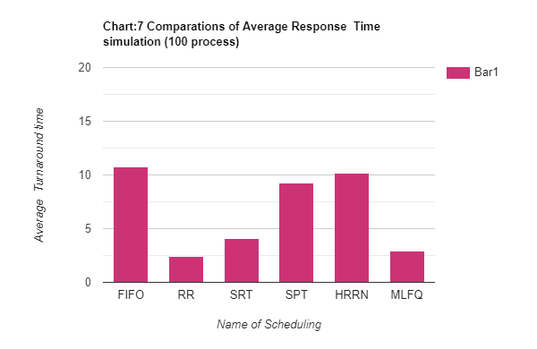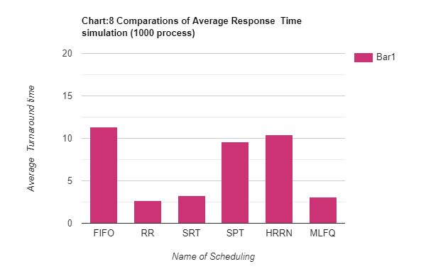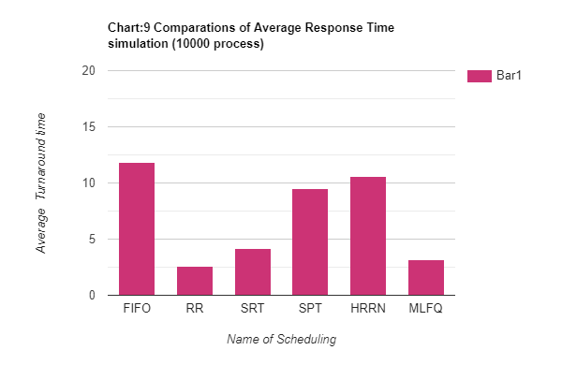

I. Round Robin had the lowest average response time among the five algorithms for all three numbers of processes (100, 1000, and 10000).

II. Multilevel Feedback Queue (MLFQ) had higher average response times compared to Round Robin.

III. The difference in response time between MLFQ and Round Robin could be attributed to the fact that Round Robin is a preemptive algorithm and can interrupt a running process to move on to the next one, while MLFQ is non-preemptive and may have to wait for a process to finish before moving on to the next one.

XI. Utilization:

The CPU utilization results in our simulation were consistent across all three process numbers (100, 1000, and 10000) and for all five scheduling algorithms. This is likely due to the fact that we used the same dataset for each simulation and did not take into account any additional factors such as multi-processor technology. It's important to note that in a real-world scenario, other factors such as the number of processors, the number of active processes, and the system load may also affect CPU utilization.

XII. Comparisons results

graphs (1-3) compare the average waiting time, average turnaround time, response time, and utilization of five algorithms, using data points of 100, 1000, and 10000. The comparison is shown from the perspective of the four metrics mentioned.
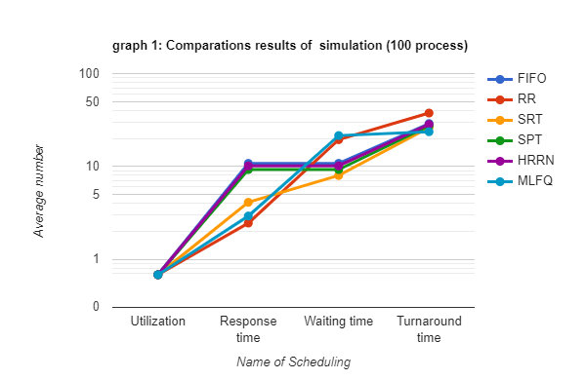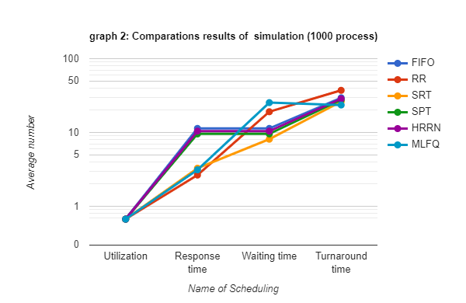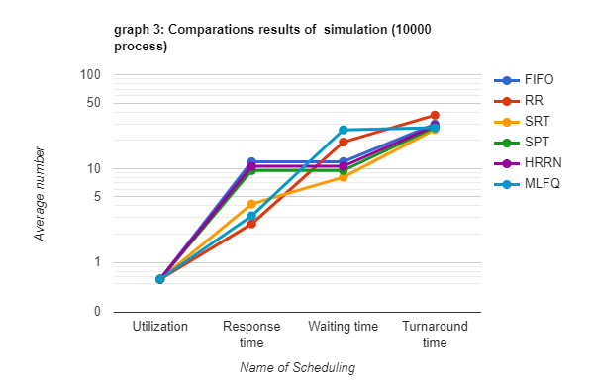

XIII. CONCLUSION

The simulation results indicate that MLFQ had higher average waiting and response times compared to some of the other scheduling algorithms, particularly Round Robin. This suggests that MLFQ may not be as responsive to new processes and may have longer waiting times between queues. However, it is important to consider the specific requirements and goals of your system when choosing a scheduling algorithm, as the performance of each algorithm can vary depending on the workload and characteristics of the processes being scheduled.

References

[1] | A. E. Evwiekpaefe, A. Ibrahim and M. N. Musa, "Improved Shortest Job First CPU Scheduling Algorithm," Dutse Journal of Pure and Applied Sciences (DUJOPAS), Vol. 8 No. 3a September, vol. Vol. 8, no. No. 3a, 2022.
[2] | Ubita and M. Sharma, "Comparison of Various CPU Scheduling," International Journal of Creative Research Thoughts (IJCRT), vol. 10, no. 6, 2022.
[3] | J. Shivani and M. Manisha, "AFTM-Agent Based Fault Tolerance Manager in Cloud Environment," The International Arab Journal of Information Technology, vol. 19, no. 3, pp. 306-402, 2022.
[4] | A. P. J.J. Sharma, "New Approach to Process Scheduling: the HRRN Algorithm," 2020.
[5] | S. Zouaou, L. Boussaid and A. Mtibaa, "Priority based round robin (PBRR) CPU scheduling algorithm," International Journal of Electrical and Computer Engineering (IJECE), vol. 9, no. 1, pp. 190-202, 2019.
[6] | W. Wang, Y. Wang and Z. Cao, "Dynamic Soft Real-Time Scheduling with Preemption Threshold for Streaming Media," International Journal of Digital Multimedia Broadcasting, 2019.
[7] | A. SILBERSCHATZ, P. B. GALVIN and G. GAGNE, Operating system concepts., 10 ed., Wiley & Sons, 2018.
[8] | G. Tomsho, Guide to Operating Systems 5th edition, Cengage Learning EMEA, 2018.
[9] | W. S.-N. Sarayut Phornchroen, "A proposed Round Robin Scheduling Algorithmfor Enhancing Performance of CPU Utilization," Przeglad Elektotechniczny, vol. 4, no. 0033-2097, 4 2018.
[10] | H. B. Andrew S. Tanenbaum, Modern Operating System, vol. 5th edition, Pearson India, 2016.
[11] | K. A. PATEL, "Analysis and Testing of Different Time Quantum for Round Robin Algoriyhm," International Journal of Advances in Electronic and Computer Science, vol. 3, no. 4, pp. 40-44, Apr 2016.
[12] | P. Ramesh and U. Ramachandraiah, "Performance evaluation of real time scheduling algorithms for multiprocessor systems," in 2015 International Conference on Robotics, Automation, Control and Embedded Systems (RACE), 2015.
[13] | W. Stallings, Operating Systems: Internals and Design Principles, 8th edition ed., Pearson, 2014.
[14] | A. P. Laplante and J. S. Ovaska, Real-Time Systems Design and Analysis, 4th eidtion ed., I. PRESS, Ed., A JOHN WILEY & SONS, INC., PUBLICATION, 2012.
[15] | T. H. L. C. E. R. R. L. &. S. C. Cormen, Introduction to Algorithms, MIT Press, 2009.
[16] | Y. Wiseman and S. Jiang, Advanced operating systems and kernel applications, 1st ed., Information Science Reference, 2009.
[17] | P. B. G. a. G. G. Abraham Silberschatz, Operating System Concepts, Wiley, 2008.
[18] | O. M. Daniel P. Bovet and Marco Cesati, Understanding the Linux Kernel,, 3rd, Ed., 2005.
[19] | A. &. S. T. M. (. Ravindran, "The multilevel feedback queue scheduler,," ACM SIGOPS Operating Systems Review, vol. 21, no. 5, pp. 53-64, 1987.
[20] | C. L. Liu, "Scheduling algorithms for multiprogramming in a hard-real-time environment., (1), 46-61.," Journal of the ACM, vol. 20, no. 1, 1973.
[21] | R. P. Kerschberg, ""A Taxonomy of Scheduling Algorithms for Multiprogramming in a Hard-Real-Time Environment," 1 JAN 1973.
[22] | M. D. K. G. A. M. a. R. W. F. ". F. J. Corbato, "The Multics System: An Examination of Its Structure," Communications of the ACM,, vol. 9, no. 1, pp. 14-21, 1966.

